Is Trusting Others Obligatory or a Preference?

Onyul Haque
Department of Psychology, University of Southern California

Is Trusting Others Obligatory or a Preference?
We trust strangers all the time. Though we are immersed in a world filled with trust, at the heart of trust behavior lies a mystery. Past work has shown that people trust complete strangers whom they will never interact with again even though they did not believe their trust would be honored (Fetchenhauer & Dunning, 2009). Across several studies, participants played a binary trust game. They are given $5. They can keep the $5 or they can give it to Player 2 at which point it becomes $20. Player 2 can keep all 20$ or give $10 back to Player 1. After recording participant’s risk tolerance and their beliefs about how many people would honor their trust, if participants were rational actors seeking to maximize profits only about 30% of them should have trusted. However, across the studies about 65% of participants decided to trust.
Why do people trust even though they believe their trust will not be honored? We argue that when faced with a trust situation people do not behave like rational actors acting to maximize profits but rather they are focused on honoring a norm of respect. The trust game is an economic game. As shown in other studies, behavior in economic games is not driven solely by the economic outcome but rather also by the social norms operating in those games. For example, past work has shown that labeling the Prisoner’s Dilemma as “The Wall Street Game” or “The Community Game” makes people act either selfishly or prosocially (Liberman, 2004). Our previous work in this area indicates that a norm of respect drives people to trust. Across two experiments (Dunning et al., 2014), the authors placed a third option in the trust game: simply have Player 2 flip a coin to see if they got their money back. However, most people still opted to trust Player 2 even though they believed their chance of getting money back was 33% which was significantly less than the odds from the coin flip. This signals that there was something about respecting the character of the person that mattered when it came to the trust game.
People honor the norm of respect when they trust but doing so appears to be more of an obligation than a preference. When participants were assessed about the norms surrounding trust - many of them felt as though they should trust despite not wanting to. Although wanting to trust predicted trust game decisions, beliefs about what they should do could explain why people trusted more than a rational actor analysis would have predicted (Dunning et al., 2014).
Likewise, agitated emotions, especially guilt, not emotions of desire, explained the excessive trust rates (Dunning et al., 2014, Schlösser et al., 2016). Other studies have documented that people often feel high levels of stress, guilt, and anxiety when they feel as though they have not fulfilled a social obligation. For example, the more Asian students believed academic achievement was obligatory - the more test anxiety they experienced (Tao & Hong, 2014). Higgins (1987), in his work on self-discrepancy, said people who have not yet attained attributes they believe “it is his or her duty or obligation to attain” will be more vulnerable to agitated emotions (p. 323). Thus, we believe the agitated emotions participants feel when they are in the trust game reflect an obligation to trust.
Other researchers have demonstrated that other seemingly prosocial behaviors are often driven by obligation rather than an honest desire to “do the right thing”. Across several studies, Dana and colleagues (2007) have shown dictators in a dictator’s game often give money because they are obligated to follow a norm of fairness. Dictators would abuse a plausible excuse to escape a norm of fairness or likewise keep themselves in the dark about the payoffs of the other person and simply maximize their own payoff.
Given (1) people’s beliefs that they should trust, (2) the agitated emotions people experience when they think about not trusting, and (3) a swathe of other independent studies showing other prosocial behavior is often obligatory – we believe choosing to trust is more of an obligation rather than a preference. More specifically we believe choosing to trust is an internal obligation or a moral norm. Moral norms are internalized, autonomous and are not affected by social pressure (Campbell, 1964). We believe trusting is a moral norm because in past studies we told participants they would have to announce their choice in the trust game publicly and it did not affect trusting rates (Dunning et al., 2014). Thus, trusting seems to be about honoring a moral norm as opposed to a social norm.
We conducted a study to provide experimental evidence and explore if choosing to trust is obligatory or a preference. We adopted one of the paradigms employed by Dana and colleagues (2007), in their work on giving behavior in the Dictator’s game. Participants are assigned to play either a lottery game or the trust game. Some participants in both games are told that they might be cut off at some random point within 30 seconds. If they are cut off, the computer will decide randomly for them. Our hypothesis is that if trust is an obligation then people should dawdle when it is possible they will be cut off so they could use the cut off as a plausible excuse to absolve themselves of responsibility over the outcome. However, this should only happen to people in the trust game where the obligation to respect is active. People should not dawdle in the lottery game where the origin of risk is nature and thus there is no obligation to respect. Therefore, we expect people in the trust game with the possibility of a cutoff to take the longest amount of time to make a choice. We also expect participants will allow themselves to be cut off more frequently in the trust game when there is a potential cutoff. Thus, our second hypothesis is that overall trust rates will be lower in the trust game timer game than in the regular trust game.
Method
Trust Game
Participants played a modified version of the trust game (Berg et. al., 1995). Participants were given $5 dollars. They were told they have been assigned to another person to play a game. Each person would know the outcomes of the decisions of the other person – but they would never personally interact with each other during or after the game. Participants learned they can do one of two things with their $5. They could either keep the $5 or they could give the other person their $5. If they gave the $5 to the other person, the experimenter would add $15 dollars so that the other person gets $20 total. Participants discovered the other person can either keep the $20 or give $10 back to the participant. The participant is told the other person has already made their decision with what they would do if they got $20 before they even know if the participant decided to keep or give the $5. Thus, participants should realize their choice to trust or not trust will not affect their odds to receive $10 back from the other person.
Lottery Game
In the lottery game, participants were given $5. We told them they have two options. They can keep the $5. Or they could use the $5 to buy a ticket to play a lottery and win $10. The odds of winning the Lottery Game were 45%. Previous studies (N = 336) indicated that people in the trust game believe there is, on average, a 45% chance the other person will honor their trust give back $10 (Fetchenhauer & Dunning, 2009). Thus, both games were comparable in terms of expectancy for success.
Procedure
The research design was a 2 x 2 (Game: Trust vs Lottery – Timer: Yes vs No). The timer conditions carried one additional feature to both games. Participants are told they have a maximum 30 seconds to choose between their two options (give $5 vs keep $5). Participants learned it was possible that at some random point within the 30 second period, the computer would cut them off. If they were cut off – the computer would randomly choose to give or keep the $5 with equal probability. The reason the computer would choose an option randomly instead of simply choosing to keep the $5 was to avoid reactivity. If participants read that if they were cutoff the computer would choose the $5 they probably would have figured out our hypothesis and change their behavior accordingly. Participants were told that if the computer chose for them – then they would not no longer be able to affect the decision and the game would be played according to whatever option was chosen. There was no random cutoff. Participants had the entire 30 seconds to decide. If they took more than 30 seconds to make a decision then they were automatically sent to the next page and no decision would be recorded. Participants in the trust game timer condition were told Person B would not know if the choice was made from the person or the computer. Thus, their choice to dawdle, hasten or answer at a normal speed would be internally motivated. After participants read about the timer features, they answered comprehension questions. Participants could take as much time as they wanted on the page with the details of the game and the comprehension questions. However, we recorded how much time they spent on this page. We wanted to control for this covariate in our analyses.
On the next page, participants waited 60 seconds with the details of the game displayed on the screen in front of them. They learned that as soon as the 60 seconds finished, they would automatically be sent to the next page to make their decision. They were also notified that as soon as they were thrown into the next page, the 30 second timer would automatically start. Participants were never presented a visible timer to keep track of their time.
After participants submitted their choices, participants who played the trust game indicated what percentage of people they thought would keep the entire $20 for themselves and how many they thought would give back $10. We collected this information to ensure that the lottery game odds were comparable to the trust game odds.
Results
In line with previous studies, participants believed that on average there was a 48% chance Person B would have given back $10. This did not significantly differ from the odds in the lottery game, t(61) = 1.18, p = 0.24.This statistic did not differ between people in the trust timer condition as well, t(25) = 1, p = .33. Neither did it differ for people in the regular trust game t(35) = .66, p = .50. Thus, there is evidence to believe that both games were equivalent in terms of expected values.
The Bayesian analysis was computed in R using the brms package. We analyzed people's decision to keep their five dollars. Participants in the timer conditions who took longer than 30 seconds to decide were re-coded as keeping their five dollars. In the lottery timer condition, nobody took longer than 30 seconds to decide; however, in the trust timer condition about 10% of the participants took longer than 30 seconds to decide. The variables that were entered as predictors in the model were the game (0 = Lottery game, 1 = Trust game) and the timer (0 = No timer, 1 = Timer) and their interaction. The priors that were set for intercept, or the parameter indicating gambling rates for the lottery game without a timer as a normal distribution with a probability of .35 and a standard deviation of .10. We chose that as our prior given the abundant research done in prospect theory we know that people are risk averse in these situations (Fox & Poldrack, 2009). For the prior of beta 2 which assesses the effect of game on gambling rates, we set it as a normal distribution with a mean of .30 and a standard deviation of 0.05. We chose an informative prior because our previous studies indicate that people are much more likely to trust in the trust game than gamble in the lottery game (Fetchenhauer & Dunning, 2009). For the prior of beta 2 which assesses the effect of timer on gambling rates, we set it as a normal distribution with a mean of -0.10 and a standard deviation of 0.05. A paper by Kocher and colleagues (2013) suggests that time pressure makes people use heuristics more in risky situations. Since people are risk averse we thus expected them to become more risk averse with the presence of a timer and withhold gambling their $5. For beta 3 which assessed the interaction of both game and timer we expected even fewer people to trust because they will allow themselves to be cut off (our hypothesis). The prior for the beta 3 was a normal distribution with a mean of .10 and standard deviation of .05 Since the dependent variable is binary, all the aforementioned priors were logit transformed to be compatible with the outcome of the model results.
As shown in Table 1, we find a significant main effect for the type of game participants played. Participants in the trust game were more likely to trust than participants in the lottery game. We find a significant effect for the effect of the timer. Participants were more likely to keep their five dollars when they were in the timer condition. Contrary to our hypothesis, we did not find an interaction effect.

Table 1
Bayesian Analysis - Gambling Rates
 |  | 95% CI for odds ratio
Predictor |  | Lower | Odds Ratio | Upper
Intercept |  | 1.96 | 2.80 | 3.95
Gameª |  | 1.53 | 1.88 | 2.30
Timer^{b} |  | 0.43 | 0.64 | .95
Game x Timer |  | 0.76 | 1.07 | 1.54
Note. Values reflect odds ratios. (0 = Did not give $5, 1 = Gave $5
ª Coding levels for Game: (0 = Lottery, 1 = Trust Game)
^{b} Coding levels for Timer: (0 = No Timer, 1 = Timer)
Figure 1
Posterior Distribution of Parameters for Gambling Rates Model
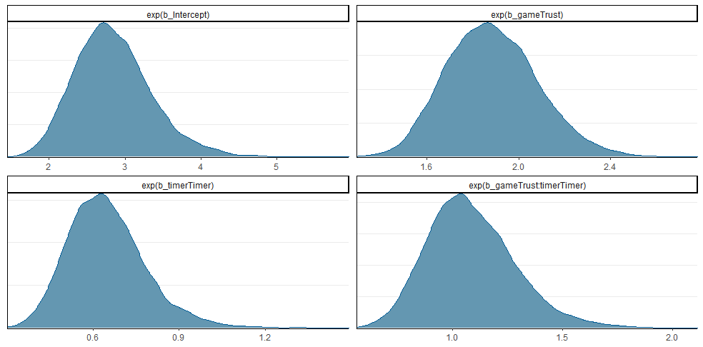
Note. Values reflect Odds Ratio
We analyzed how long participants took to decide in each condition. The raw data for reaction times were heavily skewed and thus log transformed. In this model the dependent variable was the time it took for participants to submit their decisions and the predictors were the game, the timer and their interaction. Unfortunately, we could not find a single study which has looked at reaction times in the risky situation either when the origin of risk is nature or if it is humans. Thus, the priors for all the parameters were weak. The beta coefficients followed a normal distribution with a mean of 0 and standard deviation of 1 . Likewise, the sigma component also followed a weak parameter: a t-distribution of size 4 and mean of 0 and standard deviation of 0.5.
The only significant effect is that participants in the trust game. People were more likely to take longer in the trust game regardless of the presence of the timer. Importantly we did not find an interaction effect.
Table 2
Bayesian Analysis - Reaction Times to Submit Decisions
Predictor |  | Lower | Estimate | Upper
Intercept |  | 1.60 | 1.80 | 2.02
Gameª |  | 0.61 | 0.89 | 1.20
Timer^{b} |  | -0.39 | -0.09 | 0.21
Game x Timer |  | -0.65 | -0.21 | 0.22
Note. Values in the table reflect the log transformation. (0 = Did not give $5, 1 = Gave $5)
ª Coding levels for Game: (0 = Lottery, 1 = Trust Game)
^{b} Coding levels for Timer: (0 = No Timer, 1 = Timer)

Figure 2
Posterior Distribution of Parameters for Reaction Time Model
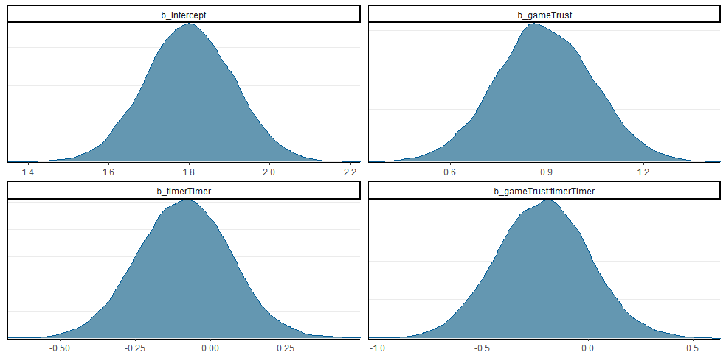
Discussion
Initially, we believed that choosing to trust others would be an obligation as opposed to a preference. Thus, we had expected participants to dawdle in the trust game when there was a timer in hopes to abuse the cutoff as an excuse to rid themselves of responsibility. However, participants did not take longer to decide in the trust game when there was a possible cutoff than participants in the other conditions. Thus, it appears our first hypothesis was off the mark. In fact, though we did not find a significant result, reaction times were going in the opposite direction than we predicted. Moreover, our second hypothesis anticipated that obligated individuals would not decide in the 30 seconds and allow themselves to be cut off. Thus, we expected lower trust rates in the trust game when there was a timer than when there was not and that this should happen exclusively in the trust game. However, people seemed to have trusted at about the same rate in both trust conditions and thus were not affected by the presence of a cutoff. Finally, we would like to highlight that participants in the trust game timer condition were told that Person B would not know if the decision was made by the computer or themselves. Thus, their actions were intrinsically motivated. Combine all these findings together and it means that people in the trust game were internally motivated to trust even when there was a possible cutoff to absolve them of the responsibility. Despite our expectation that trusting others would be an internal obligation, the evidence we collected here suggests trusting others is an internal preference.
In future studies, we would like to verify this finding with other manipulations which tease apart obligation versus preference. According to Cain and colleagues (2014) there are at least two types of avoidance behaviors through which obligations are expressed: exit and strategic ignorance . The exit strategy involves “secretly avoiding a request for help or preventing others from knowing that one can fulfill the request” (p. 513). For example, when dictators in a dictator’s game were given the opportunity to pay a small amount of money to exit the game without the recipient knowing they did - giving rates diminished (Dana et al., 2006). Strategic ignorance involves “choosing not to know the consequences of their own actions” (p. 515). Importantly the authors note that strategic ignorance must be a passive choice. In one study, they told participants the consequences of their actions would be revealed by default unless the dictator actively clicked a button to keep themselves in the dark. In that situation nearly nobody chose to keep themselves in the dark about the consequences of their actions. The idea would be to employ these avoidance strategies in future studies as experimental manipulations to see if we replicate our results.
We thought trusting others would be an obligation, yet our results suggest it may be a preference. Nevertheless, our past work on trust was reaffirmed by this study. Most people in the regular trust game trusted above and beyond what a rational actor model would suggest they would, and moreover, they seem internally motivated to do so. We also stumbled upon an unexpected research path which will be fun to explore. Namely, why do people take much longer to bet on people than nature? I have not been able to find another study which has directly compared reaction times between betting on nature versus human nature. Perhaps answering this question can shine some light on whether trusting others is an obligation or a preference. Despite our current results, the question of whether trusting others is an obligation, or a preference is still an open case, and we hope to explore it in different ways.

References
Berg, J., Dickhaut, J., & McCabe, K. (1995). Trust, reciprocity, and social history. Games and economic behavior, 10(1), 122-142.
Cain, D. M., Dana, J., & Newman, G. E. (2014). Giving versus giving in. The Academy of Management Annals, 8(1), 505-533.
Campbell, E. Q. (1964). The internalization of moral norms. Sociometry, 391-412.
Dana, J., Weber, R. A., & Kuang, J. X. (2007). Exploiting moral wiggle room: experiments demonstrating an illusory preference for fairness. Economic Theory, 33(1), 67-80.
Dunning, D., Anderson, J. E., Schlösser, T., Ehlebracht, D., & Fetchenhauer, D. (2014). Trust at zero acquaintance: more a matter of respect than expectation of reward. Journal of Personality and Social Psychology, 107(1), 122.
Fetchenhauer, D., & Dunning, D. (2009). Do people trust too much or too little?. Journal of Economic Psychology, 30(3), 263-276.
Fox, C. R., & Poldrack, R. A. (2009). Prospect theory and the brain. In Neuroeconomics (pp. 145-173). Academic Press.
Higgins, E. T. (1987). Self-discrepancy: a theory relating self and affect. Psychological review, 94(3), 319.
Liberman, V., Samuels, S. M., & Ross, L. (2004). The name of the game: Predictive power of reputations versus situational labels in determining prisoner’s dilemma game moves. Personality and social psychology bulletin, 30(9), 1175-1185.
Kocher, M. G., Pahlke, J., & Trautmann, S. T. (2013). Tempus fugit: time pressure in risky decisions. Management Science, 59(10), 2380-2391.
Schlösser, T., Fetchenhauer, D., & Dunning, D. (2016). Trust against all odds? Emotional dynamics in trust behavior. Decision, 3(3), 216.
Tao, V. Y., & Hong, Y. Y. (2014). When academic achievement is an obligation: Perspectives from social-oriented achievement motivation. Journal of Cross-Cultural Psychology, 45(1), 110-136.

In the original study, the researchers gave their participants a maximum of 10 seconds to decide. However, preliminary data revealed that participants in the Trust Game consistently took longer than 10 seconds to decide. We wanted to give participants a reasonable time to decide in both games, so we increased it to 30 seconds.

